Comp Title:
Continuation of your comp title
Your Name
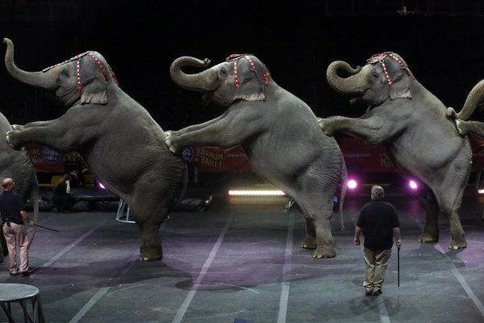
Abstract (100 words in 18-20 point Calibri) - In the 133 years since P.T. Barnum bought his first one, no animal has been so closely identified with the circus as the elephant, starring under the big tents, adorning posters and ritually announcing the circus’ arrival with a gawk-worthy parade into town — in the case of New York, through the Midtown Tunnel.
But after decades of animal rights activists claiming that it treats the giant creatures cruelly, Ringling Brothers and Barnum & Bailey announced Thursday that its three touring circuses, performing 1,000 shows a year, would phase out elephant acts by 2018.
Spring 2020

